1. 
2. **Agenda**:
   1. How to set up different URLs to test the same APIs against different servers 🡺 localhost, test, production.
3. Graphical user interface, text, application

   Description automatically generated
4. Graphical user interface, application

   Description automatically generated
5. Graphical user interface, application

   Description automatically generated
6. 
7. Table

   Description automatically generated
8. Table

   Description automatically generated with low confidence
9. Graphical user interface, text, application

   Description automatically generated
10. Graphical user interface, text, application

    Description automatically generated
11. 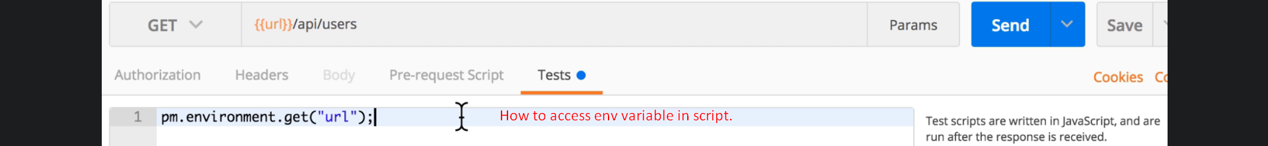
12. Graphical user interface

    Description automatically generated with low confidence
13. sGraphical user interface, application

    Description automatically generated